

MATHEMATICS
YEAR 8 - PATHWAY 2

Investigation 2 – Perimeter and Area
Semester 2 2019

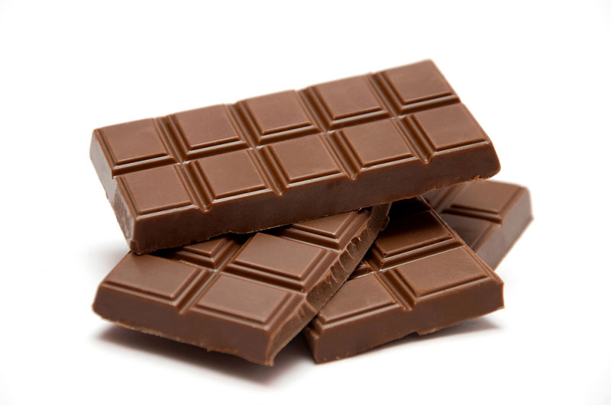

Information for Students

Working time: 45 minutes
Marks available: 32 marks
CALCULATORS ALLOWED: Mobile phones are to be placed in bags at the front or rear of the classroom.

Mrs Byrne loves chocolate! She is obsessed with chocolate and wants to make sure she is getting the most chocolate possible. She has to choose one of these blocks of chocolate.
A
B

C
D

- [6 marks] Complete the following table for each of the shapes above.
Shape | A | B | C | D
Size(dimensions) | 7 by 1 | 6 by 2 | 5 by 3 | 4 by 4
Perimeter
Area

- [1 mark] What do you notice about the perimeter of each of the blocks of chocolate?

- [2 marks] Which block of chocolate do you think that Mrs Byrne will choose? Explain why?

- [6 marks] Now draw all possible rectangular blocks of chocolate that have a perimeter of 24. (NOTE: a square is a special rectangle.

Question 5 and 6 relate to the shapes you have just drawn on the previous page.
- [8 marks] Use the table below to record results from Question 4, using the shapes you have just drawn. Label each of your shapes with a capital letter.
Shape
Size (dimensions)
Perimeter
Area

- [2, 1 = 3 marks]
- Which shape has the largest area and what is this area?

- What is the name of the shape of the block of chocolate with the largest area?

Questions continued on the next page…

7. [4,2 = 6 marks]
a) Test your answer to Question 6.b) by considering a block of chocolate with perimeter of 12cm. Use the grid below for your diagrams.

c) Write a concluding sentence on your findings.

End of Investigation

